Brady Heinz 4.2 Assignment 2/8/2026
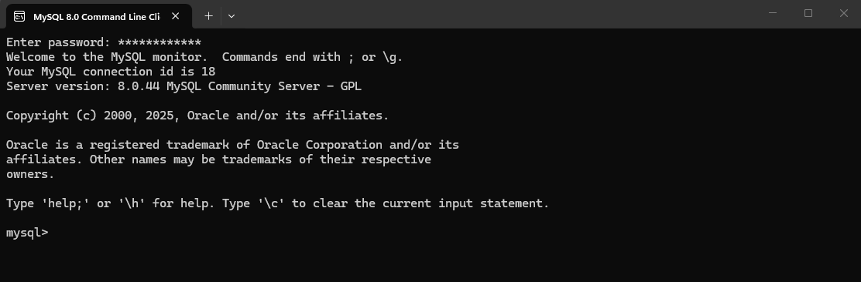
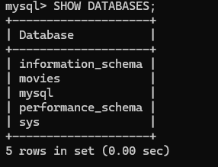
CONCAT can be used for you to have first name and last name in different columns, and you want to display them as one.
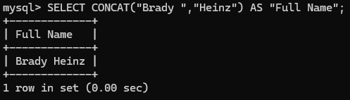
Right can be use if you only want to show the last four digits of a SS number
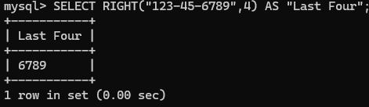
CURRENT_TIMESTAMP can be used if you need to put a time stamp on an update that you ran
